complexity or simplicity? an example THE AGRO-FOOD INDUSTRY
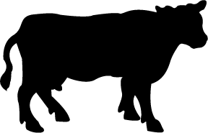
Grain-based Beef Production in Modern Agriculture

A functionally integrated network of production, trade and service activities that covers all the stages in a supply chain, from the transformation of raw materials, through intermediate manufacturing stages, to the delivery of a finished good to a market. . . . . Each successive node within a commodity chain involves the acquisition or organization of inputs for the purpose of added value.

The process in which several steps in the production and/or distribution of a product or service are controlled by a single company or entity, in order to increase that company's or entity's power in the marketplace.

The sum total of all operations involved in the manufacture and distribution of farm supplies; production operations on the farm; storage; processing and distribution of the farm commodities and items made available from them.

So what?
Why?
Where?
When?

