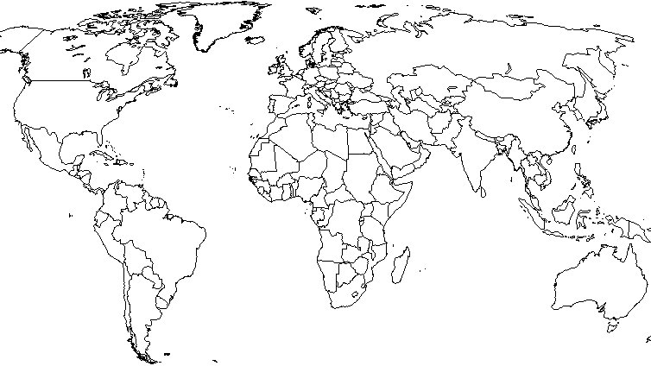
categorilla HIGHEST AND LOWEST TFR*
Highest TFR |  |  | Lowest TFR
1 | Niger |  | 210 | Latvia
2 | Uganda |  | 211 | Poland
3 | Mali |  | 211 | Slovenia
4 | Somalia |  | 213 | Romania
5 | Burundi |  | 213 | Moldova
6 | Burkina Faso |  | 215 | Ukraine
7 | Ethiopia |  | 216 | Bosnia and Herzogovina
8 | Zambia |  | 217 | Belarus
9 | Angola |  | 217 | Czech Republic
10 | Congo |  | 220 | Lithuania
11 | Mozambique |  | 221 | South Korea
12 | Malawi |  | 222 | Japan
13 | Afghanistan |  | 223 | Taiwan
Are any regions present? What observations can you make?

What questions do you have about the data portrayed on this map? Does it raise any concerns? How would you summarize the message or importance of this map?

*Source: Nationmaster.com, from a list including 227 “countries”
Teacher notes
Mini and microstates which are also within the SLOWEST growing ten…
Monaco
Hong Kong
Singapore
San Marino
Macau
Greece – 206
Italy -205
Austria -202
Germany -201

