CATEGORILLA Best & Worst Countries to be a Woman
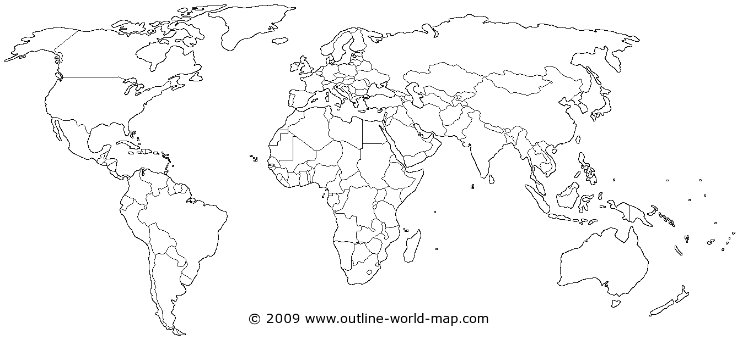
Top 10 Best Countries for Women Top 10 Worst Countries for Women

What are some things the best countries for women have in common?

What are some things the worst countries for women have in common?

What surprised you the most about this article/data?

