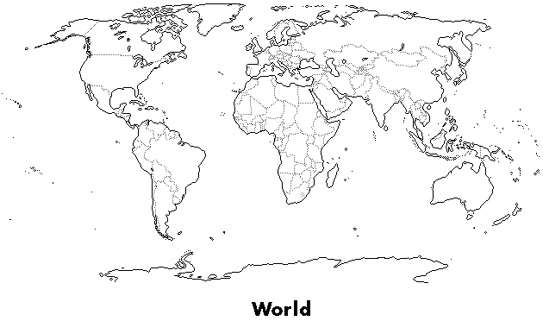
categorilla ISLAMIC COUNTRIES
*Source: Nationmaster.com

Countries with the  LARGEST TOTAL NUMBER of Muslims* |  |  | Countries with the  HIGHEST PERCENTAGE of Muslims*
Indonesia | 195,272,000 |  | Saudi Arabia | 99.998%
Pakistan | 160,829,450 |  | Somalia | 99.996%
India | 154,500,000 |  | Maldives | 99.9%
Bangladesh | 129,681,509 |  | Mauritania | 99.895%
Turkey | 72,750,000 |  | Comoros | 99%
Egypt | 69,560,000 |  | Yemen | 99%
Iran | 68,805,000 |  | Algeria | 99%
Nigeria | 65,750,000 |  | Djibouti | 99%
China | 39,111,000 |  | Afghanistan | 99%
Ethiopia | 36,032,160 |  | Tunisia | 99%
THREE OBSERVATIONS

TWO SUPRISES

ONE SPATIAL or GEOGRAPHIC IDEA

