Listening Guide China & Taiwan
History of China and Taiwan
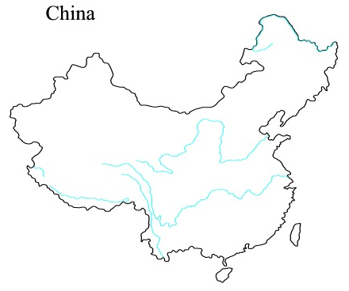

Language Gap

Character Debate

Confusion

