Ethnic Conflict Project
- Select, with your group, one ethnic conflict zone and put your names next to it on the teacher’s master list.

- Balkans (Yugoslavia)  - Caucuses  - Congo  - Darfur/Chad & Sudan  - East Timor  - Gaza Strip  - Kashmir  - Kenya  - Kosovo | - Pakistan  - Russia (Chechnya)  - Rwanda  - South Sudan (internal)  - Spain (Basque, Catalonia)  - Sri Lanka  - Uganda  - Zimbabwe
*Let me know if you have another current or historical conflict that you would like to research.

- Research your selected zone with your group and complete the Research Graphic Organizer.
- Include at least two visuals that help illustrate what the conflict is about or reveal the intensity of the conflict. For example, they could be symbols used by conflicting religious groups or ethnic murals used against each other.
- Include a world map that you can use to pinpoint where the conflict is taking place. Also, find a large- scale map that can better show the territory in question.
- Organize the information for your presentation.
- Create the presentation.
- Create a script or a list of talking points that will be used for the presentations. Please make sure that you address all of the components of the Graphic Organizer in your presentation. The presentation should be around 5-7 minutes.

Ethnic Conflict Project
- Select, with your group, one ethnic conflict zone and put your names next to it on the teacher’s master list.

- Balkans (Yugoslavia)  - Caucuses  - Congo  - Darfur/Chad & Sudan  - East Timor  - Gaza Strip  - Kashmir  - Kenya  - Kosovo | - Pakistan  - Russia (Chechnya)  - Rwanda  - South Sudan (internal)  - Spain (Basque, Catalonia)  - Sri Lanka  - Uganda  - Zimbabwe
*Let me know if you have another current or historical conflict that you would like to research.

- Research your selected zone with your group and complete the Research Graphic Organizer.
- Include at least two visuals that help illustrate what the conflict is about or reveal the intensity of the conflict. For example, they could be symbols used by conflicting religious groups or ethnic murals used against each other.
- Include a world map that you can use to pinpoint where the conflict is taking place. Also, find a large- scale map that can better show the territory in question.
- Organize the information for your presentation.
- Create the presentation.
- Create a script or a list of talking points that will be used for the presentations. Please make sure that you address all of the components of the Graphic Organizer in your presentation. The presentation should be around 5-7 minutes.

Research Graphic Organizer Name:

Country/region:

What lies at the root of this conflict? (Why?)
What form does this conflict take (i.e., tension, discrimination, open violence)? (How?)
What is the spatial extent of the conflict? (Where?)
What is the timeframe of the conflict? Is it still going on? (When?)
How many people have been affected? In what ways? (Who?)
Examples of how this conflict presents itself at a global, regional and local scale. (Spatial effects?) Ex:  Global: The conflict in Nigeria led the Miss World Pageant to move its location in 2002. | Local: Regional: Global:

Ethnic Conflict Graphic Organizer
World Map | Country/Region | Root of the Conflict | Timeframe | Spatial Impact
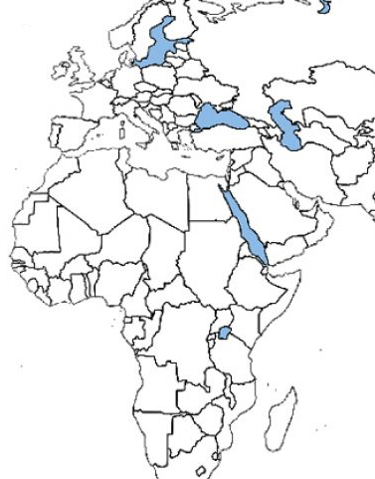

World Map | Country/Region | Root of the Conflict | Timeframe | Spatial Impact
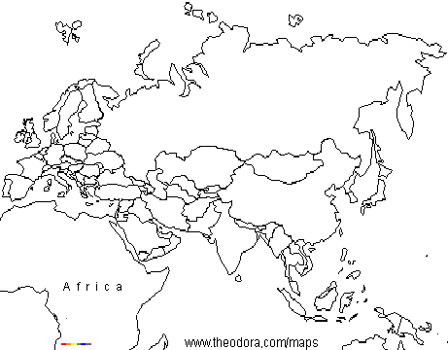
*Please note whether the conflict is ongoing or not.

