Ethnicity Case Study Kurds
Read the history of the Kurdish ethnic group. Write a 3-4 sentence summary of the history and current situation of the Kurdish people.

Fill in the map with the Kurdish inhabited areas using the following website: http://www.khrp.org/kurds/kurdish-region-map.html
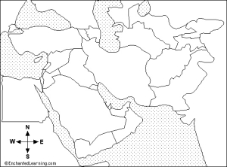
Read about other Kurdish regions using the following website: http://www.khrp.org/kurds/the-kurds-today.html and summarize the main issues the countries are facing below:
Iran

Iraq

Syria

Turkey

The Caucasus

What options are available to ethnic Kurds in these regions?

Modified from http://cmes.arizona.edu/sites/cmes.arizona.edu/files/1.%20Assignment%20Description%20%28for%20teachers%29.pdf

