[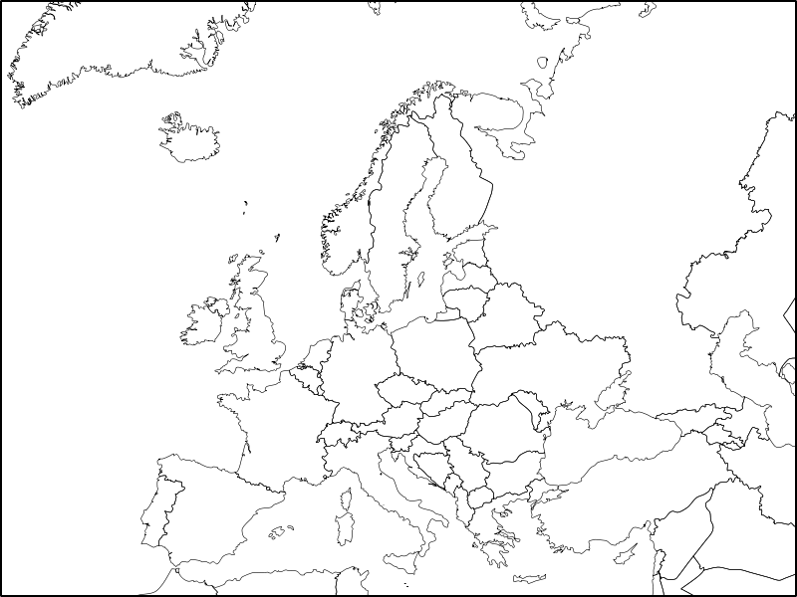](http://upload.wikimedia.org/wikipedia/commons/e/e5/Europe_political_chart_complete_blank.svg)