checking connection strength **THE GRAVITY MODEL**

The relative strength of a bond between two places is determined by multiplying the population of place A by the population of place B and then dividing the product by the distance between the two placed squared.

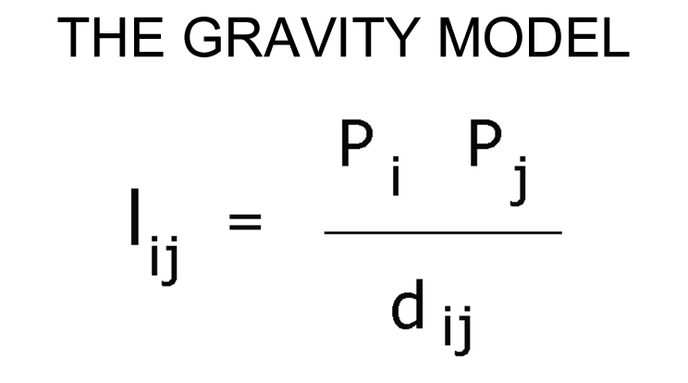



o

or

To find the distance between two places, use the Distance Calculator:

<http://www.geobytes.com/CityDistance.htm>

To find the populations of smaller cities, use the Population Calculator

<http://www.city-data.com/>

To find the populations of larger cities use this site with MSA Population Data

<http://www.citypopulation.de/USA-Metro.html#Stadt_gross>

**ASSIGNMENT**

1. Choose 1 city.
2. Choose 3 other cities or towns that you’d like check and compare the connection strength to, that is, check the gravity.
3. Do the calculations.
4. Summarize your findings with a map and caption in which you discuss the gravity of City 1 and its connection strength to the other three cities.