Economic Comparison
of Taiwan and Hong Kong
by Justin Sarang,
April 2002
Taiwan is located off the southeastern coast of China, just north of the Philippines. It is a relatively small island with an approximate population of just over 22.2 million. Its main nationality is Chinese and the official languages spoken are Mandarin and Taiwanese. Taiwan’s natural resources include small deposits of coal, natural gas, limestone, and marble.
China had control over Taiwan until 1895 when a military defeat forced China to cede Taiwan to Japan. After World War II, Taiwan reverted to Chinese control. In 1949, two million Nationalists fled to Taiwan after a communist victory on the mainland. Over the past six decades, Taiwan has slowly democratized their infrastructure and markets. During this period, it has prospered and has become an economic powerhouse in the world. Other major historical events that happened in Taiwan were the beginning of Martial Law in 1949, The San Francisco Peace Treaty in 1951, The Shanghai communiqué in 1972 and the Kaosiung Incident in 1979. The dominant political issue however has been the continuous argument of reunification with China.
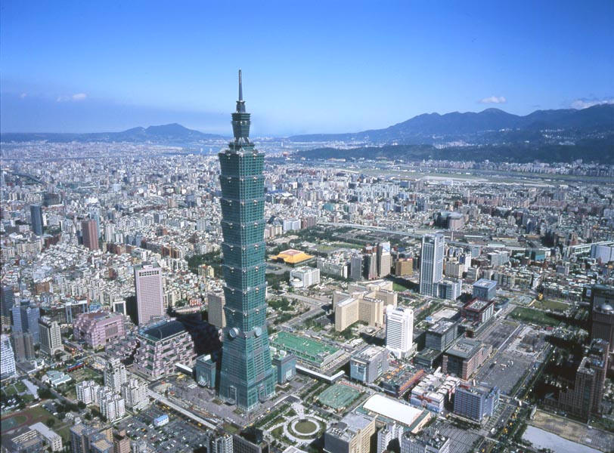
Hong Kong is also located off the southeastern coast of China. It is a significantly smaller island than Taiwan and has a population of approximately 6.7 million. The main nationality is Chinese and the languages that are primarily spoken are Cantonese, Mandarin, and British English. Hong Kong has no real natural resources except a deep-water harbor and an industrious population. They advocate and practice free trade with a government policy of maximum support and minimum intervention.
After the end of the first Opium War, the Treaty of Nanking in 1842 ceded Hong Kong to Britain. In 1937, when the Sino-Japanese War began, Japan began to advance into China. This sent hundreds of thousands of Chinese into Hong Kong into refuge. Then in 1941 on Christmas Day, the British surrendered Hong Kong to the Japanese. However, the U.S. foiled Japanese plans to use Hong Kong and the British retained the territory in 1945. Since then, Hong Kong has developed into an international financial, trading and business center. On July 1, 1997, Hong Kong became a Special Administrative Regime of the People’s Republic of China after a century and a half of British rule.
Taiwan’s national identity lies in the people’s belief that Taiwan is an independent State. It has been that way since 1949 and has prospered ever since with a capitalist economy. People in Taiwan understand that they are ethnic Chinese, but feel pride in being a Taiwanese immigrant. They feel a special attachment towards the place they have spent all or most of their lives. The Taiwanese compare they’re livelihood to that of Americans because although they are ethnically diverse, they are still very proud to be an American. If you ask many residents on the street of Taiwan what represents national identity, they will tell you that being Taiwanese is what makes them who they are.
Since Hong Kong has reverted to China in 1997, there is a stronger awareness of residents of their identity being Chinese rather than Hong Kongers. Even though Hong Kong uses two systems to run their country in which China is a part of, there is certain pride among residents to be accepted as Chinese and not looked upon as Chinese living in Hong Kong. The people of Hong Kong once thought of themselves as British territory residents. Now, they believe that they are united with China and know where they came from and are proud to be Chinese.
Both Taiwan and Hong Kong want national identity of being where they have spent all of their lives. They both comprehend the fact that all once came from China and so did certain customs and rituals, but they have patriotism for the country that took them in and nurtured them. Taiwan has stronger views on national identity than Hong Kong partly because they have not become part of China. One thing that remains true for both countries however is that the people of both of these countries will decide their future and national identity and no one else.
Taiwan has a capitalistic economy with a decreasing guidance of investment and foreign trade by government authorities. Real GDP has averaged 8% over the past three decades. Hong Kong also practices free trade and its government has little intervention. Real GDP in Hong Kong has been lower on average of 6.5% per year. Both countries have become leading trading and financial centers. They are two of Asia’s “Four Tigers” which has means that they have the highest per capita GNP and highest standards of living in Asia. Inflation rates in the year 2000 in Hong Kong were –3.7 compared to Taiwan’s .4% which means markets have been doing well and their currency is strong compared to other countries. Both countries’ major trading partner is China in which totaled $89.2 billion for Hong Kong and $50 billion for Taiwan in 2001. Both countries’ will spend well over $50 billion to be invested in the next 15 years on major rail, road, land, and communications projects. This will provide tens of thousands of jobs and spur economic growth. Taiwan’s government is made up of a multiparty democratic regime headed by a popularly elected president. The legislative branch is popularly elected and the judicial branch is composed of appointed justices by the president with consent of the National Assembly. Under Hong Kong’s Basic Law, the existing economic, legal, and social system will be maintained for at least 50 years after the reunification in 1997. The executive authorities and legislature is composed of permanent residents and the judicial branch is independent of China in which power rests in the Court of Final Appeals. Overall, both countries uphold their own procedures in the legislative and judicial aspects of government. Although Taiwan has a more democratic regime, Hong Kong does not use China’s administrative laws and adheres to their Basic Law system.
Both Taiwan and Hong Kong are two of the world’s leading producers and exporters of consumer products. They have been providing countries with clothing, textiles, electronics and other goods for the past two decades and continue to have a trading surplus. Both countries’ major trading partner has been China, which will help them even further because China is blossoming into a financial and trading powerhouse. Both of these countries also have little tariffs and low regulations on export/imports, which give them a competitive advantage on industrialization and infrastructure growth. They share similar exports, but differ in imports that they bring in. For example, Hong Kong needs to import every natural resource as well as water and food. Taiwan on the other hand does have some agriculture and even though they manufacture electronics, they import it as wells as machinery. Both remain focal trading centers in southeast Asia and will remain leaders in export to the world for a long period of time because they have secured healthy ties to the U.S and China and because their products are always in demand.

