Iranian Rap Music Bedevils the Authorities

Rough-edged underground musicians connect with the disaffected, under-30 crowd.
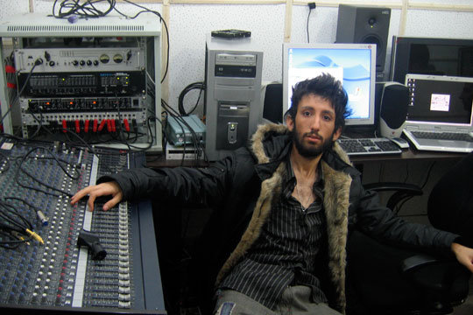
Iranian rapper Felakat was recently arrested in a crackdown on illegal music.
By Anuj Chopra March 12, 2008
TEHRAN, IRAN—In a cozy soundproof recording studio housed in a decrepit building here, the rap musician known as Felakat lounges on a chair, surrounded by sound mixers and other sleek recording gizmos. Sporting a tousled black shirt, a slick fur jacket, and a rumpled and spiky hairstyle, the Iranian rapper might well pass for a punk icon. "I devoted my life to rap when I was just 15," says the 27-year-old Felakat, which means "miserable" in Farsi. "Rap is my god."
Felakat is well aware of the perils of his musical choice. Rap is forbidden in Iran. Even so, Felakat and numerous other rap musicians are the demigods of Iran's underground music scene—which encompasses any group that fails to obtain a recording license from Iran's stern Culture Ministry and distributes its albums illegally through the flourishing black market.
Felakat has a considerable following in a nation where 70 percent of the population is under 30. He coyly admits his female fans have "become fanatical" in the year since the release of "Nazgol," his hit track themed on love and fidelity. "I've had to change my mobile phone number twice," he says with a grin, a cigarette dangling between his lips.
Hello, hip-hop. With the introduction of satellite television in Iran in the early 1990s—also illegal—and the popularity of American artists like 2Pac and Eminem, hip-hop music found an explosive following among the Iranian youth. Eventually the young Iranians turned to creating this genre of music in Farsi.
Rappers mimic American rap artists in Farsi, indulge in obscene lyrics (mostly unprintable American slang), and often use female voices as leads or background voices—all jarring symbols of western decadence in the eyes of Iranian authorities who blame such music for luring the youth away from Islamic culture. Mohammad Dashtgoli, a Culture Ministry official, was recently quoted in the Iranian press as saying that rap is not inherently objectionable. "But due to the use of obscene words," he said, "rap has been categorized as illegal."
Still, a variety of rap musicians has emerged in Iran in the past few years. Zedbazi, for instance, introduced gangsta rap with its song "Mehmooni" (or "In the Club"). The most famous rapper, Soroush Lashkari, who styles himself with the screen name Hich Kas (or "Nobody") is popular as the "father of Persian rap."
And despite the prohibition on women singing in public, female rappers also dot the Iranian music landscape. The first of the female hip-hop and rap artists was Salome, who lives in Tehran and focuses on social issues like prostitution and the miseries of the war in Iraq. Mana, another female rapper from Tehran, is famous for "Rebellion," a song about poverty and runaway girls in Iran.
Given the restrictions, CDs of rappers are sold illegally or passed from hand to hand, copied with little regard to copyrights. However, Iranian rappers also get their music out to the global Iranian community through websites like rap98.com and parshiphop.com . Rappers have also invaded YouTube.
But despite the fame, there's little profit in the business. Most CD shop owners refuse to sell underground music, fearing raids by authorities. If caught, they face imprisonment and hefty financial penalties. Concerts at private gatherings occasionally get canceled because of threats from ad hoc neighborhood Islamic vigilantes. "This is why many of us try to migrate abroad," says Felakat.
In late April last year, when the authorities launched a crackdown on fashion, they also took steps to curb underground music. Some musicians were jailed, their recording studios raided and shut down. Most singers were freed once they promised not to produce any more underground music. Felakat was one of those arrested, later released on bail after his father posted his house as security.
On the whole, rap is emerging as a form of protest music, as rappers defy authorities. "Any music—even rap—is not un-Islamic," says Mahmoud, 25, a composer, whose rap screen name is "dot S." He has composed up to 100 Iranian songs, 80 of which are rap. Only two, which have religious themes, have official approval. "There's hardly any motivation to seek clearance," he says. "If we adhere to their red lines, rap will be ruined."
Although defiant, most rappers do steer clear of political themes lest they invite even more severe crackdowns. For his part, dot S looks to the future. "If rap becomes legal," he says, "my albums would sell like hot cakes."

Source: http://www.usnews.com/news/world/articles/2008/03/12/iranian-rap-music-bedevils-the-authorities?page=2

Discussion Questions
- Explain the status of rap in Iran.
- How did rap music become popular in Iran?
- Describe the role women play in producing Iranian rap music.
- How is rap music sold in Iran?
- Why do you think rap music is banned in Iran? Do you agree/disagree? Why or why not?
- What type of diffusion is rap music in Iran? How does this represent the culture between folk and popular culture?

