LISTENING GUIDE AGRICULTURE REVOLUTION
What is the difference between commercial and subsistence agriculture?
DEVELOPING COUNTRIES
(Intensive Land Use, Labor Intensive, Subsistence)

Regions of the world:
DEVELOPED COUNTRIES
(Extensive Land Use, Capital Intensive, Commercial)

Regions of the world:

DEVELOPED COUNTRIES
(Extensive Land Use, Capital Intensive, Commercial)
- Mixed crop and livestock
- Dairying
- Grain
- Ranching
- Mediterranean
- Commercial gardening

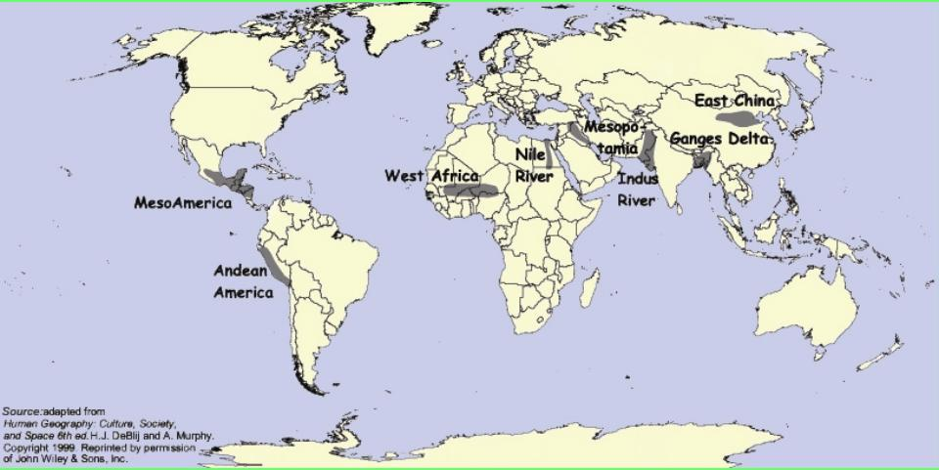
What was the 2nd agricultural revolution?

What was the 3rd agricultural revolution?

What is the opposition to the 3rd agricultural revolution, or Green Revolution?

