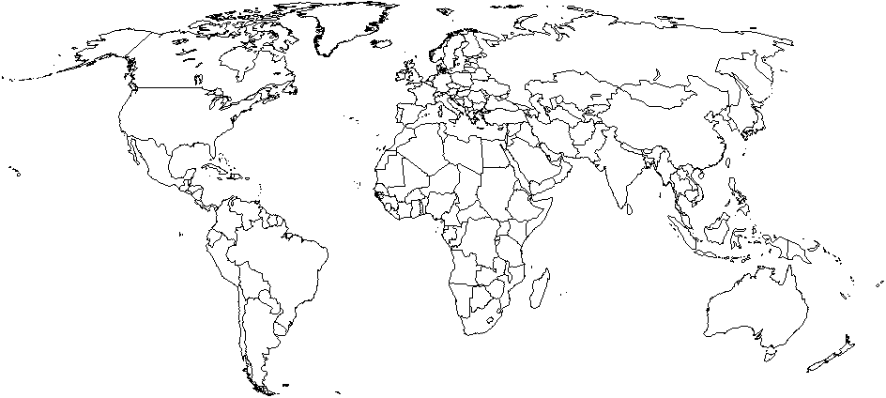
Annotate hearth areas/cities and diffusion patterns of the four largest religions.

What are the four largest religions in the world? About how many adherents does each have?

What is the difference between a memorial space and a sacred space? How are they similar?

