LISTENING GUIDE LOCATION THEORIES
Weber’s Least Cost Theory accounts for the ________________ of a __________________ plant in terms of the owner’s desire to ____________________ three costs:
- _______________: The most important and involves moving ___________ materials to _____________ and _____________ goods to _____________.
- _______________:
- ____________________________
  - _______________ Industries must be located where the __________________ are.
  - _______________ Industries are less dependent on resource location because raw materials can be transported if _____________ outweigh the costs of ___________________.

Agglomeration:

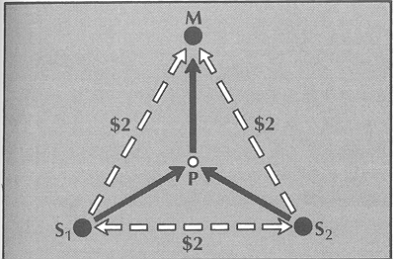
Three generalizations of Weber:
- Using ________ materials in the production process will always dictate a market location.
- __________-_______ materials usage will pull the plant ___________ to the sources
- _________________ location is chosen most often

Criticisms of Weber
- Substitution Principle:
- Model suggests one particular site is optimal, but the business could flourish in more than one area.
- Policies such as ________________ are not accounted for.

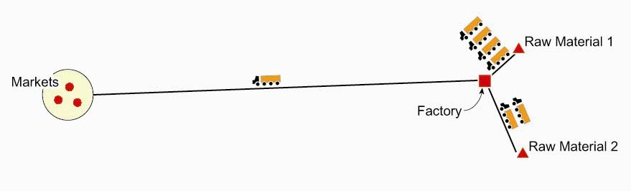
______ _______________ Oriented
Usually occurs when raw materials ______ weight in the production process such as steel.

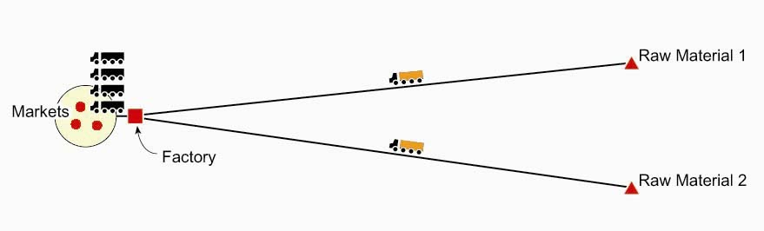
____________ Oriented
Occurs when a product is more ___________ to transport than ______ materials so the tendency is to locate near population centers. (ex. Beverages)

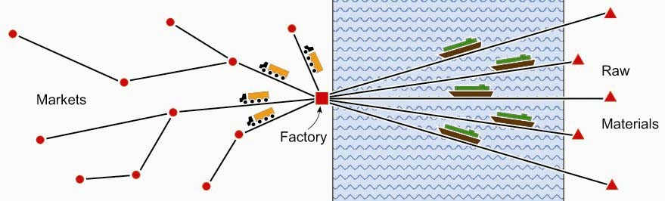
________-___-________ Oriented
Location is between sources of raw ___________ and ____________. For products that must be divided and shipped from a central point of entry.

Hotelling’s _______________ Interdependence Model:

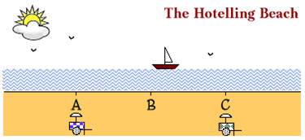

Locsh’s Zone of _________________ Model:

