LISTENING GUIDE ETHNICITY
Difference between ethnicity and race:

Ethnic distributions in the U.S.
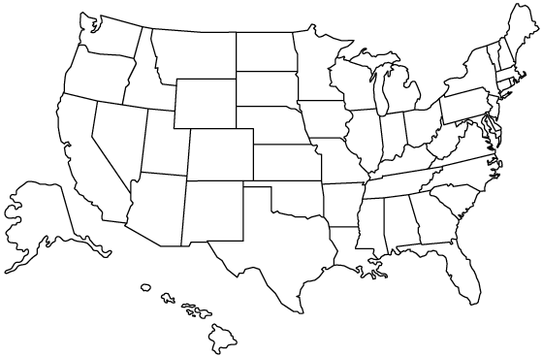

Hispanic:
African American:
Asian American:
American Indian:

Three Major Migration patterns of African Americans:

What is the difference between ethnicity and nationality?

What are some examples of ethnicities clashing?

Where does most ethnic cleansing happen today?

