distribution of culture CULTURE REGIONS

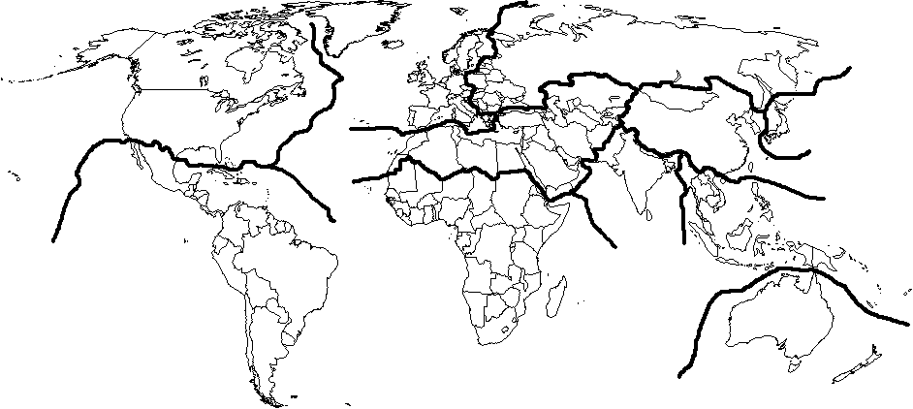
Cultural Realm (macrocultural region)

REGION | RELIGION-LANGUAGE | ANOMOLY
Anglo-America
Latin America
Western Europe
Eastern Europe
Middle East
Sub-Saharan Africa
South Asia
East Asia
Southeast Asia
Australia/Pacific

distribution of culture CORE-DOMAIN-SPHERE MODEL

The Core is the heart of the area and shows the most strongly expressed culture traits. It is usually the most heavily populated... The Domain surrounds the Core and though it has its own cultural values, it is still strongly influenced by the Core. The Sphere then surrounds the Domain and the Outlier surrounds the Sphere.
(geography.about.com)
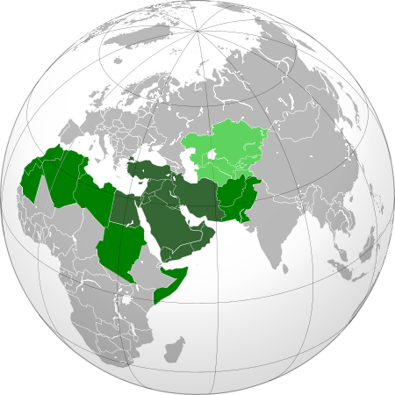
MORMON CULTURE REGION MUSLIM CULTURE REGION
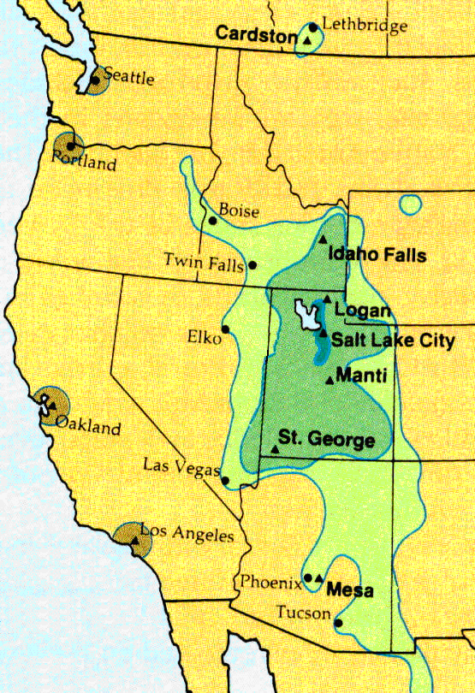
CORE | All the elements are present | The culture dominates.
DOMAIN | Many of the elements are present | The culture is obvious, but does not dominate.
SPHERE | Some of the elements are present | The culture is present, but is not obvious.
(OUTLIERS)

