HISTORY OF THE PROBLEM: BRITAIN AND IRELAND

A Centuries-old Conflict
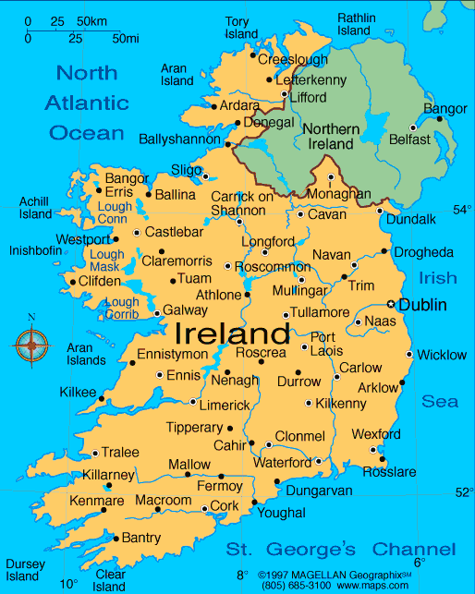
The history of Northern Ireland can be traced back to the 17th century, when the English finally succeeded in subduing the island after successfully putting down a number of rebellions. (See Oliver Cromwell; Battle of the Boyne.) Much land, especially in the north, was subsequently colonized by Scottish and English Protestants, setting Ulster somewhat apart from the rest of Ireland, which was predominantly Catholic.

The Nineteenth Century
During the 1800s the north and south grew further apart due to economic differences. In the north the standard of living rose as industry and manufacturing flourished, while in the south the unequal distribution of land and resources—Anglican Protestants owned most of the land—resulted in a low standard of living for the large Catholic population.

The Twentieth Century
Political separation of Northern Ireland from the rest of Ireland did not come until the early 20th century, when Protestants and Catholics divided into two warring camps over the issue of Irish home rule. Most Irish Catholics desired complete independence from Britain, but Irish Protestants feared living in a country ruled by a Catholic majority.

Government of Ireland Act
In an attempt to pacify both factions, the British passed in 1920 the Government of Ireland Act, which divided Ireland into two separate political entities, each with some powers of self-government. The Act was accepted by Ulster Protestants and rejected by southern Catholics, who continued to demand total independence for a unified Ireland.

The Irish Free State and Northern Ireland
Following a period of guerrilla warfare between the nationalist Irish Republican Army (IRA) and British forces, a treaty was signed in 1921 creating the Irish Free State from 23 southern counties and 3 counties in Ulster. The other 6 counties of Ulster made up Northern Ireland, which remained part of the United Kingdom. In 1949 the Irish Free State became an independent republic.

"The Troubles"
Although armed hostilities between Catholics and Protestants largely subsided after the 1921 agreement, violence erupted again in the late 1960s; bloody riots broke out in Londonderry in 1968 and in Londonderry and Belfast in 1969. British troops were brought in to restore order, but the conflict intensified as the IRA and Protestant paramilitary groups carried out bombings and other acts of terrorism. This continuing conflict, which lingered into the 1990s, became known as "the Troubles."
Despite efforts to bring about a resolution to the conflict during the 1970s and 80s, terrorist violence was still a problem in the early 90s and British troops remained in full force. More than 3,000 people have died as a result of the strife in Northern Ireland.

The Northern Ireland Conflict
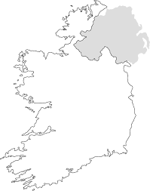

What are the historical roots of the Northern Irish conflict?

Who are the main groups involved in the Northern Irish conflict?

What is the status of the Northern Irish conflict today?

