Station 1
WDTH?
(When did that happen?)

- Look at the 2 maps for this station.

- Complete the chart on your worksheet to provide the toponym changes that occurred, the absolute and relative location of the change, and explain why the change happened.

Think about the events in history that you know!
Oh, and do this four times…hence the four rows on the chart!

Station 2
Flags have colors,
but States have shapes!
For each of the six shapes (yes, I included landlocked)…
- identify a country by coloring it
- add it to the key
- draw and color the country’s flag near by

Station 3
No Trespassing!
Use the highlighters provided to identify as many boundaries as possible (at least one of each) on your blank world map.
- physical
- cultural (this includes geometric)
- antecedent
- subsequent (consequent or superimposed)
- relic
Station 4
Stop Fighting!!!
Use the highlighters provided to identify as many areas of border conflicts as possible. Be sure to label at least one of each kind.
- Positional/definitional
- Territorial/locational
- Functional/operational
- Resource/allocational

Why the Change? |  |  | 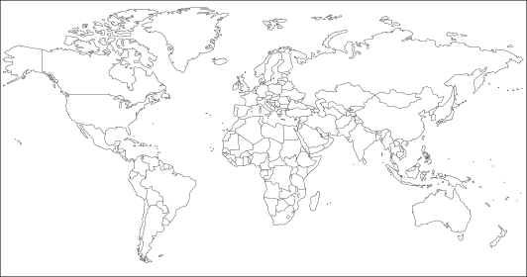
Location A & R
Toponyms

