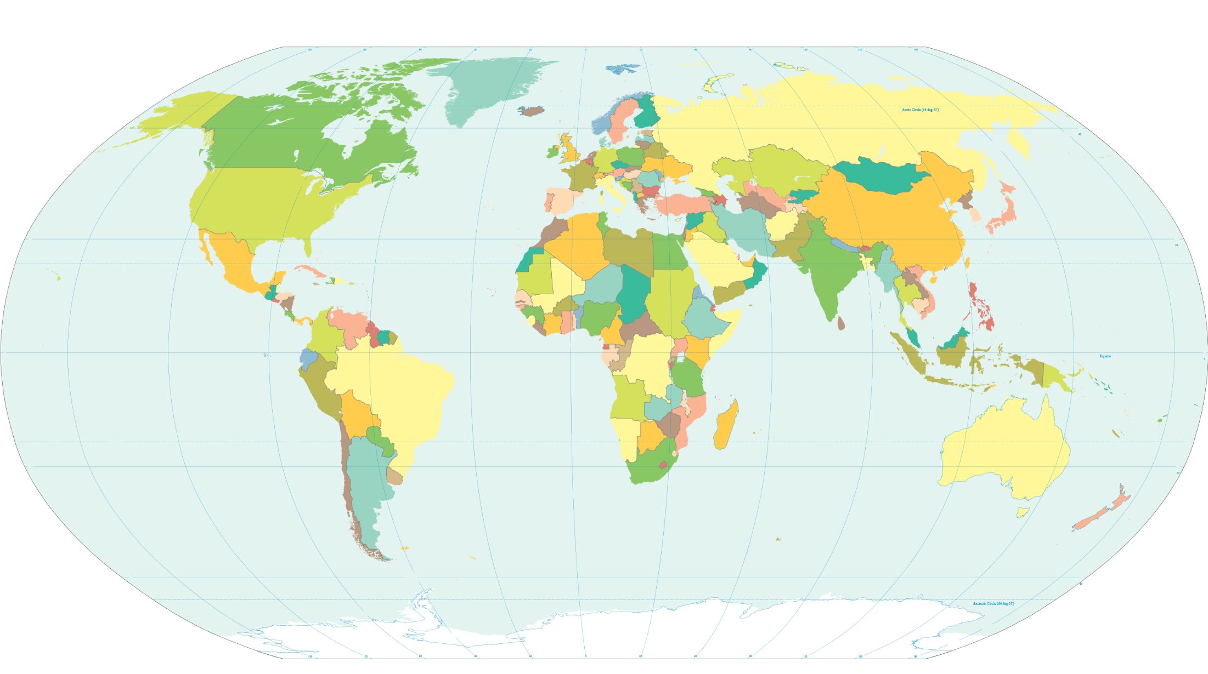
Primate City or Rank Size Rule?

A = Primate City
B = Rank-Size Rule

Country | Most Populous City Name | Most Populous City Population | 2nd Most Populous City Name | 2nd Most Populous City Population | Primate or Rank-Size Rule? | Largest population also Capital City?
Australia
Brazil
Cameroon
Canada
China
Egypt
Finland
Germany
India
Kuwait
Madagascar
Malaysia
Mongolia
Nigeria
Russia
South Africa
Sudan
Tanzania

http://en.wikipedia.org/wiki/List_of_capitals_and_largest_cities_by_country,

