reading a thematic map DOT DISTRIBUTION MAP
1. Identify areas of highest concentration/density. Why?

2. Identify areas of lowest concentration/density. Why?

3. Identify areas where the change gradient is the steepest. What is changing?

4. Identify areas where the change gradient is most gradual.
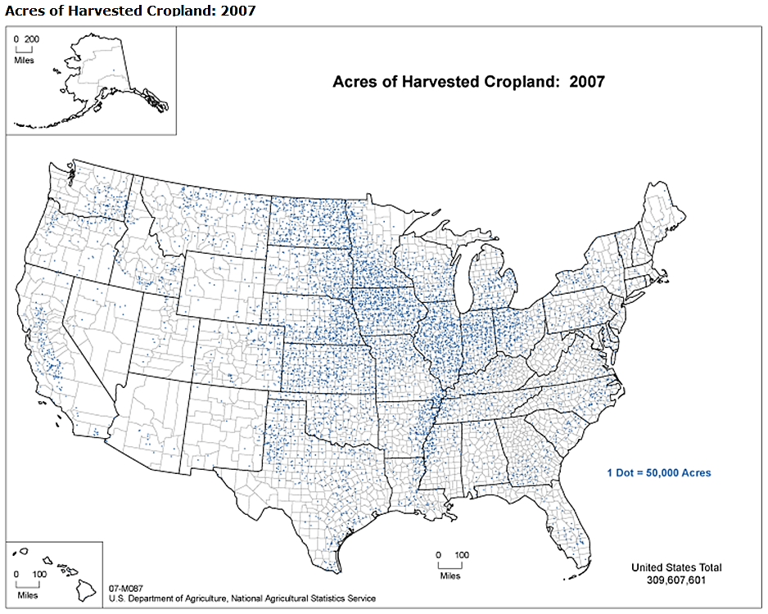

reading a thematic map CHOROPLETH MAP
1. Into how many classes is the information divided?
- Does it seem like enough? too many?
- Can you readily identify the different classes?

2. How have the break points been determined?
- How much difference is there between the lowest and the highest classes? What does it indicate?

3. Is the choice of color/shading affecting the way the map appears?

4. Think about the scale at the which data is portrayed. What is it?
- What are some important differences you might see if you could change the “resolution” of the map? That is, what might you see if you could show the data at a different scale?
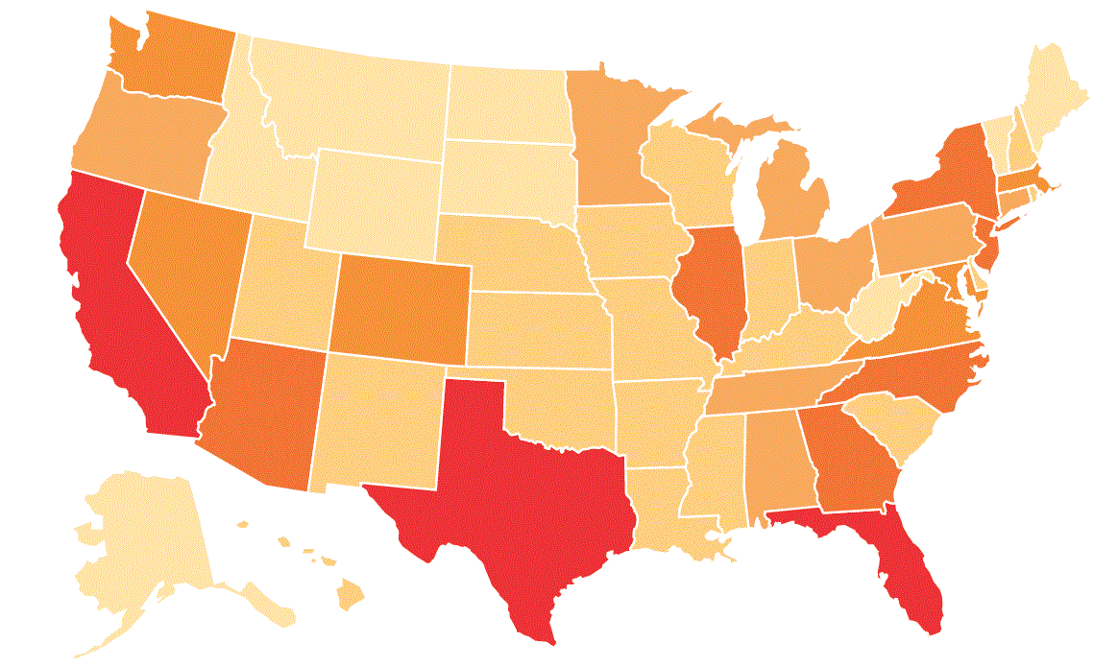
Concept: Chris Hall, Davis School District (UT) Graphic: Deseret News, Sunday June 27,2010
Concept: Dave Lanegran, Macalester College (MN). Adapted for use by teachers by Chris Hall, Davis School District (Utah). Map source: US Department of Agriculture (agcensus.usda.gov).

