Shapes of States

Type of State | Examples | Comments
Compact: Small, circular country. |  | Easiest type of state to govern.
Elongated Rectangular – more length than width. Ease of governing depends on how extreme the elongation is. |  | Chile is the most extreme example in the world (4,000 miles long|150 miles wide). Ability to govern the area depends largely on how extreme the elongation is.
Prorupted  Has an appendage that reaches out to access a natural resource or population. |  | Appendages can reach to the ocean to keep an area from being landlocked, can give a country access to a natural resource, or a group of people. These are moderately hard to govern, because appendages are very narrow and can create choke points.
Fragmented Country is physically split into different pieces. |  | Many island countries are fragmented. Having several separate pieces can make it very hard to govern, as the government cannot always control the different pieces allowing for separatist groups to emerge.
Perforated Country completely surrounds another, smaller country. |  | The presence of another state within the borders of a country can disrupt accessibility. Good relations with the state are essential.

Shape of the State
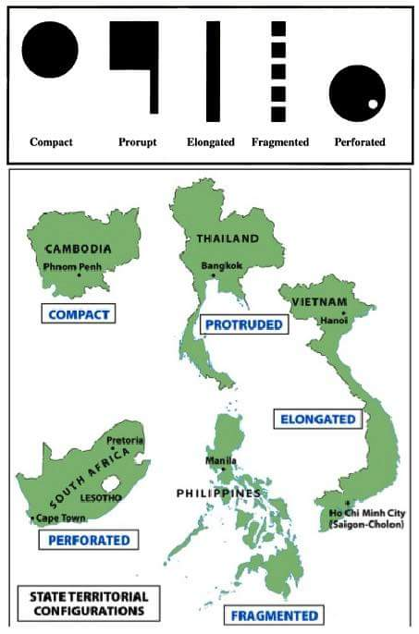
State Morphology
The boundaries of a country and the shape of the land which it encompasses can present problems or it can help to unify the nation. The shape or morphology of most countries can be divided into five main categories: compact, fragmented, elongated, perforated, and protruded.
Compact
A compact state with a circular shape is the easiest to manage. Belgium is an excellent example because of the cultural division between Flanders and Wallonia within Belgium. The compact form of Belgium has helped to keep the country together.
Fragmented
Nations such as Indonesia, which is composed of more than 13,000 islands, are known as fragmented or archipelagic states (because they are composed of archipelagos). It is difficult to govern such a country composed of islands (and more than 200 million people). Denmark and the Philippines are also archipelagic countries separated by water.
Elongated
An elongated or attenuated nation such as Chile makes for difficult governance of peripheral areas in the north and south from the central capital region near Santiago. Vietnam is also an elongated state.

Perforated
South Africa is the classic example of a perforated state, which completely surrounds Lesotho. The surrounded nation can only be reached by going through one country. If there is hostility between the two nations, access to the surrounded nation can be difficult.
Italy is also a perforated state. Both Vatican City and San Marino are surrounded by Italy.
Protruded
A protruded or panhandle country such as Myanmar (Burma) or Thailand have an extended arm of territory. Like an elongated state, the panhandle complicates that shape of the territory. The state of Oklahoma also has a prominent panhandle.

