Sustainability of Water Resources in the Colorado River Handout
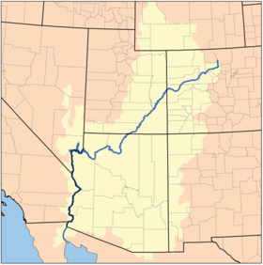
Environmental Pillar | Economy Pillar | Society Pillar

What are some examples of possibilism in the southwest, in relation to the Colorado River?

What are some options available to promote sustainability in the Colorado River Basin?

