[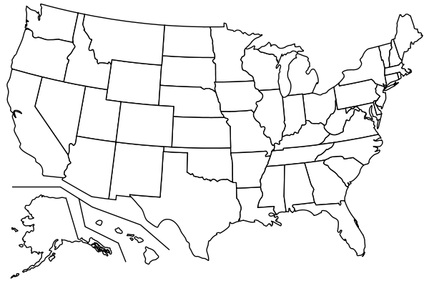](http://tertuliadofado.com/blank-us-map-printable/blank-us-map-printable-pdf/)United States-Map A